Q1 | Create a table named Playlists with columns: id, user_id, playlist_name, and total_likes. Insert at least 8 sample rows with different users and playlists, making sure some playlists have the same user_id.
Code | #create table playlists1 and insert record  CREATE TABLE Playlists1 ( id INT AUTO_INCREMENT, user_id INT, playlist_name VARCHAR(100), total_likes INT, PRIMARY KEY(id) );  INSERT INTO playlists1 (id, user_id, playlist_name, total_likes) VALUES (1, 1, 'Workout Mix', 500), (2, 1, 'Chill Vibes', 350), (3, 2, 'Rock Classics', 700), (4, 2, 'Party Hits', 450), (5, 3, 'Romantic Songs', 600), (6, 3, 'Travel Tunes', 300), (7, 4, 'Morning Motivation', 800), (8, 4, 'Sleep Music', 500);
Output | 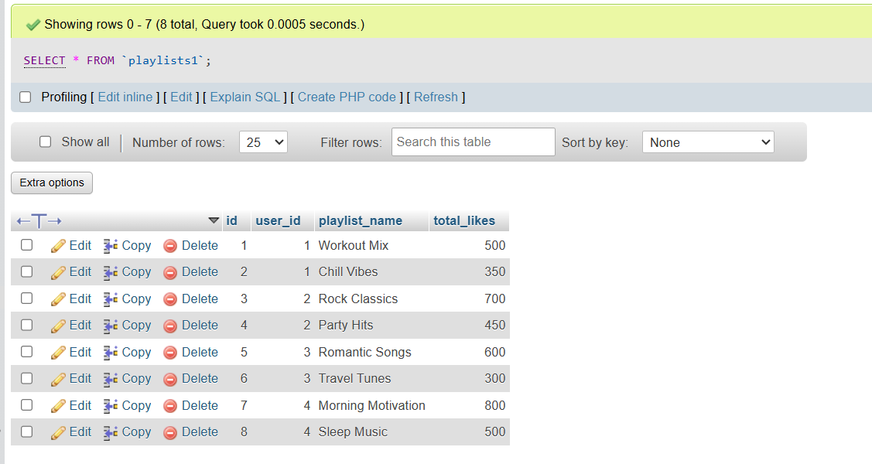

Q2 | Write a SQL query using ROW_NUMBER() and the OVER() clause to assign a unique row number to each playlist, ordered by total_likes in descending order.
Code | SELECT playlist_name, user_id, total_likes, ROW_NUMBER() OVER (ORDER BY total_likes DESC)AS Row_Number FROM playlists1;
Output | 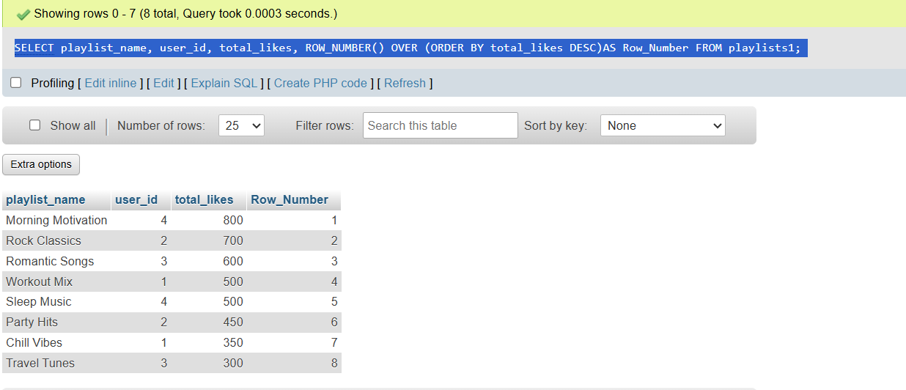

Q3 | Use the RANK() function with the OVER() clause to rank all playlists by total_likes, and display the playlist_name, user_id, total_likes, and their rank.
Code | SELECT playlist_name, user_id, total_likes, RANK() OVER (ORDER BY total_likes DESC) AS Playlist_Rank FROM playlists1;
Output | 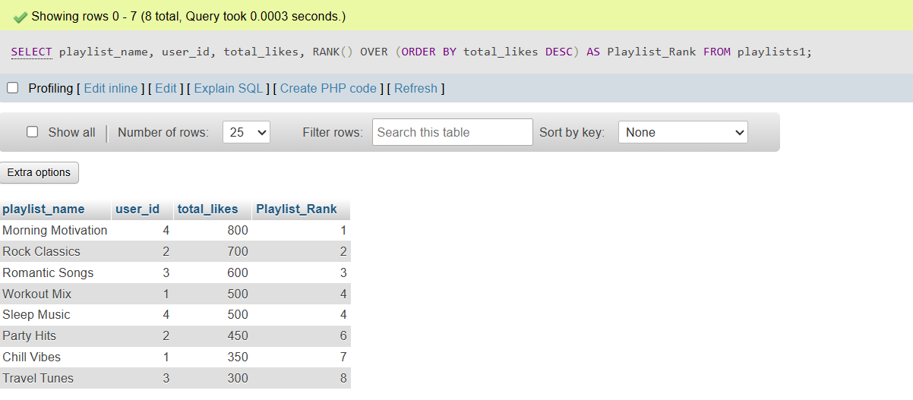

Q4 | Write a SQL query using DENSE_RANK() and PARTITION BY user_id to rank each user's playlists by total_likes, showing playlist_name, user_id, total_likes, and dense rank.<br><br><em><strong>Hint:</strong> This will show how popular each playlist is within each user's account, similar to how Spotify might rank your top playlists.</em>
Code | SELECT user_id,playlist_name,total_likes, DENSE_RANK() OVER (PARTITION BY user_id ORDER BY total_likes DESC)AS DENSE_ROW from playlists1;
Output | 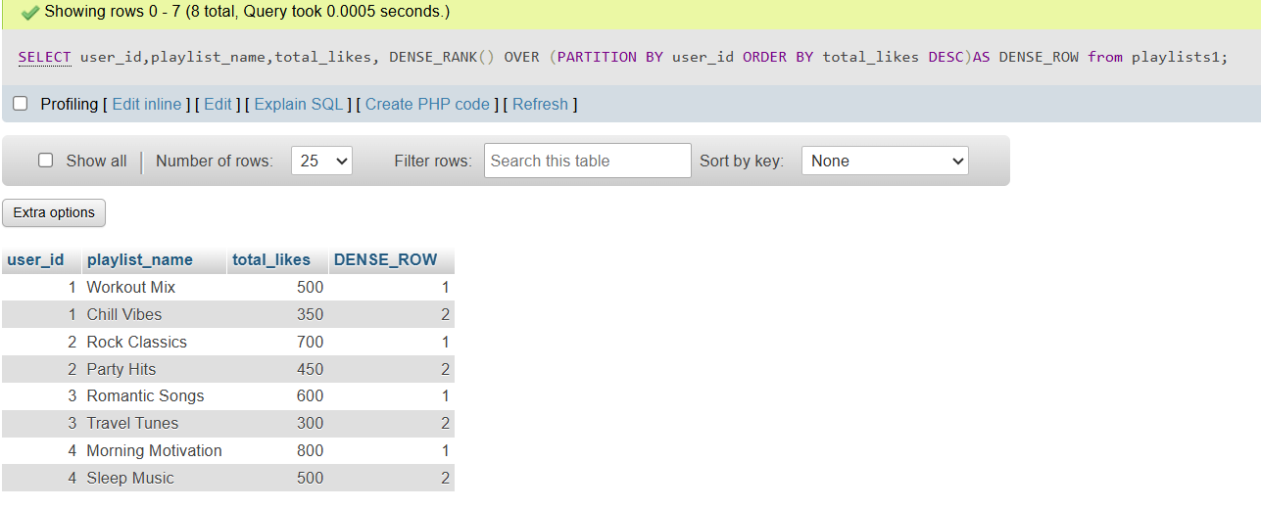

Q5 | Imagine you want to show the top 2 playlists per user based on total_likes, like Spotify's 'Your Top Playlists' feature. Write a query using a window function to select only the top 2 playlists for each user
Code | SELECT playlist_name, user_id, total_likes FROM ( SELECT playlist_name, user_id, total_likes, ROW_NUMBER() OVER ( PARTITION BY user_id ORDER BY total_likes DESC ) AS rn FROM playlists1 ) AS Ranked_Playlists WHERE rn <= 2;
Output | 